C PROGRAMMING TO FIND FACTORIAL OF A GIVEN NUMBER WIT USING RECURSION

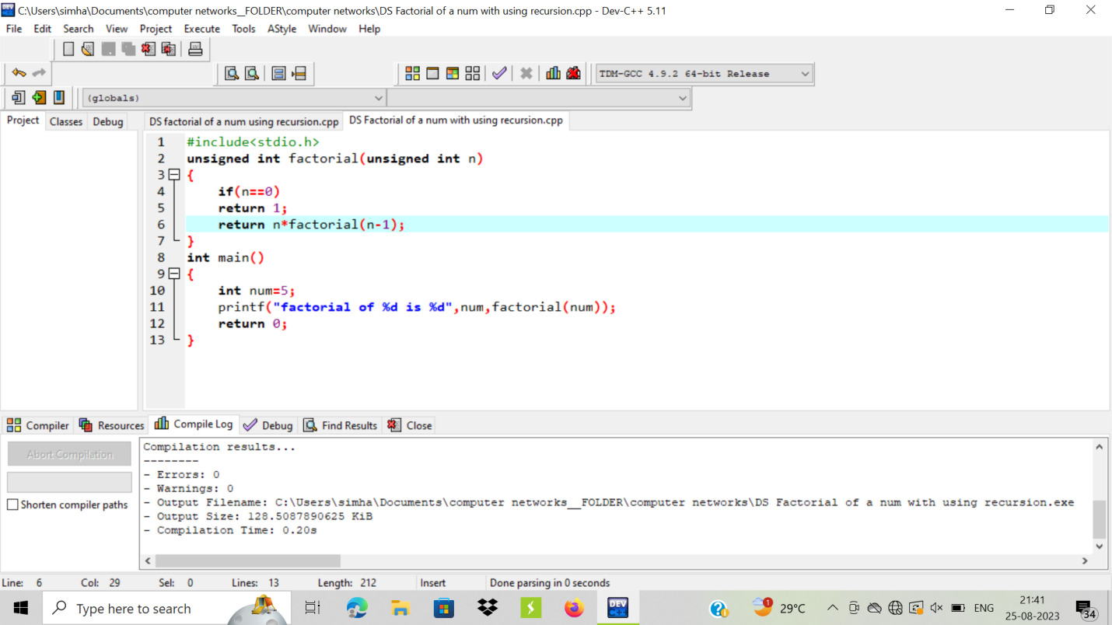

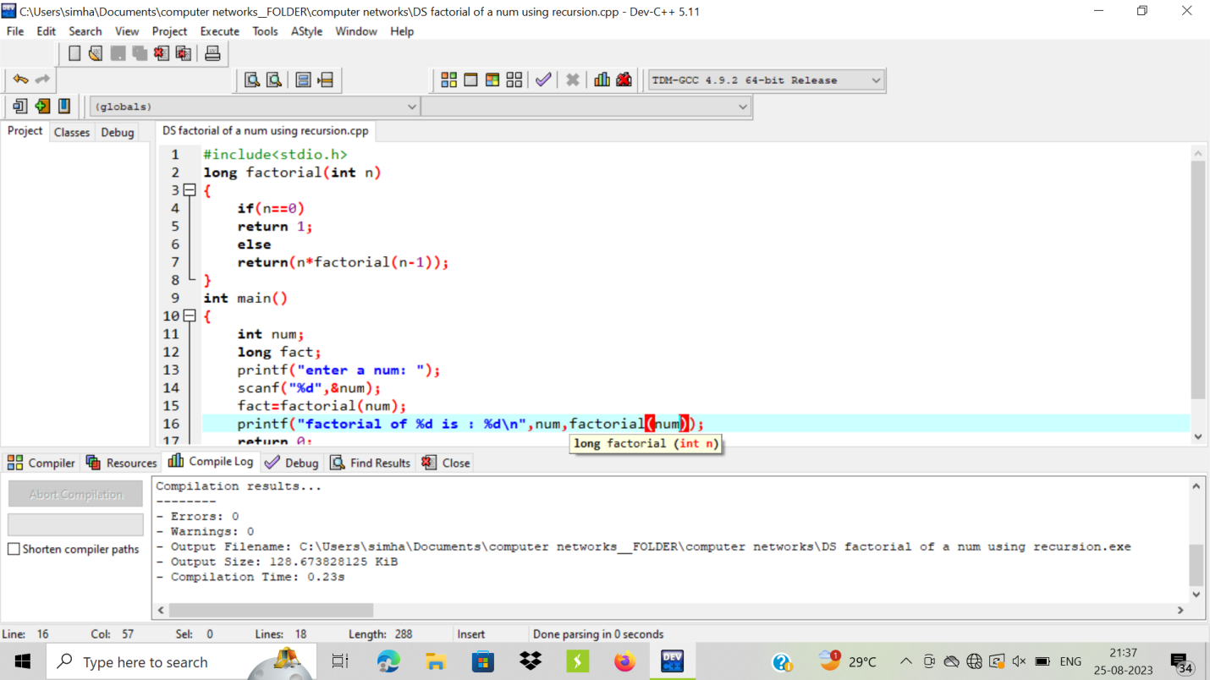

OUTPUT:

